Welcome to IH Budapest…

… and thank you very much for enquiring about our DELTA course. Note that our upcoming September 2022 – June 2023 course is 100% online, i.e. all input, teaching practice and tutorials will take place via Zoom or a similar platform.

Below you will find a description of the course, the application form, test, and the course dates and fees. There is also a brief “Pre-Delta” reading list, as many applicants have asked for this before applying; note that this is not a definitive list, and there’s plenty else you can read before the course that will help you prepare.

You need to complete the application form and test and submit them to the Teacher Training Department at International House Budapest. If these are satisfactory, then we will invite you in for an interview, or arrange one by phone if you can’t come in to the school. Your acceptance on the course is dependent on the interview.

Please make sure that you give us both a work and home phone number if possible to speed up the process. If you have not heard from us within 2 working days, then please contact us.

The DELTA application is quite extensive and demanding, and requires a considerable amount of work. If at any point you have questions about the application, do not hesitate to contact us; and if you are not sure whether you have the background required for acceptance onto the course, feel free to contact me for a chat about it (or e-mail me at ttraining@ih.hu and put my name on the subject line).

Steve Oakes
Head of Teacher Training
IH Budapest Teacher Training

APPLYING FOR THE COURSE

Read the course description so that you are informed about course content and requirements, then fill out the application form that follows. Please submit your form by uploading it on our website: www.teacher-training.hu/pages/delta_dates. Alternatively, you may email the completed application to us at ttraining@ih.hu.
Our other contact info is:
International House Budapest
1024 Budapest, Retek u. 26. 1st floor.
1056 Budapest, Váci u. 63. 2nd floor.
Phone +36 30 101 1632
WHAT IS THE DELTA?

The AIMS of the DELTA, briefly summarised, are to improve candidates’ understanding of...

- the English language and its description
- practices and principles of teaching
- a specialist area of teaching (for example, 1-1, young learners, ESP)
- procedures for formal/informal assessment of students, courses, self

...and to further their development as teachers through cultivating reflective practice.

Course requirements include:

- 120 contact hours between candidates and course tutors, primarily “input”—seminars and workshops on different aspects of language and language learning
- 4 hours of assessed lessons
- 10 hours directed observation (peer observation)
- 150 hours reading, research, and assignments—read on for details on these.

THE ASSESSED ELEMENTS

Note that while all three modules may be taken independently of each other, our extensive course comprises Modules 1 and 2 and preparation for the assessment of those modules. In March, when we enter candidates for the June exams, you can decide which modules to enter for in that session.

MODULE 1: Understanding Language Methodology and Resources for Teaching – This is assessed through a written exam taken at the end of the course in the first week of June. It is comprised of two 90-minute papers taken on either side of a 30-minute break. Candidates are prepared for this throughout the course. In both papers, candidates are given authentic texts and ELT texts to comment on and evaluate. There are a variety of tasks, including defining terminology, commenting on students’ written work and evaluating ELT material in light of learners and principles.

Note that if you wish to take the M1 exam in a location other than IH Budapest, it is possible to arrange but may incur some costs (e.g. invigilation, or travel costs if you need to travel to a centre to sit the exam).

MODULE 2: Developing Professional Practice – During the course, candidates gradually build up a portfolio of their work, the guidelines for which are provided at the beginning of the course. Altogether there are 5 assignments:

- 4 Language Systems/Language Skills assignments each submitted in two parts—a background essay summarising the candidate’s research in the given area; and a lesson plan, observed lesson, and post-lesson analysis. The assignments vary in their focus: 2 look at a separate aspects of language systems (grammar, lexis, phonology, discourse), and 2 at separate aspects of language skills (one receptive – reading or listening; and one productive – writing or speaking). Three of these are assessed by course tutors, while one is assessed by an external assessor.

- 1 Professional Development Assignment comprised of two main parts:

Part A: Reflection and Action. This is worked on throughout the course. The candidate reflects on strengths and weaknesses in their teaching, and identifies an action plan for development. They then comment on developments they have made over the course.

Part B: Experimental Practice. Candidates select a lesson approach or teaching technique with which they are unfamiliar; they research and write about it, and then teach a lesson based on it. They then reflect on the experimental lesson and develop action points for future practice in this area.

MODULE 3: Extending Practice and English Language Teaching Specialisation - Candidates select a specialist area such as young learners or 1-1 teaching. They review key theory and practice within this area and design a short course taking into account the principles of course planning (such as needs analysis and syllabus types) and assessment (principles such as validity, reliability and practicality, and types of test). Candidates produce an extended assignment of between 4000 – 4500 words, to be submitted at the start of June or December. This assignment is submitted electronically to Cambridge. Please note our extensive course is only comprised of Modules 1 and 2. We offer separate tuition for Module 3 to those who successfully complete Modules 1 and 2.

TEACHING PRACTICE

This is an essential part of the course, for developmental purposes and for assessed lessons. Candidates on our extensive DELTA course need to have their own online classes for this purpose; these groups must consist of adult learners and have at least five students. You’ll need to teach assessed lessons at two different levels. Check with the institution you teach for to make sure that it will be no problem for a tutor to observe your lessons online.

WORKLOAD

Justifiably, this is the biggest concern of anyone considering the DELTA. Input on the extensive course is only once a week for 3 hours, but a significant amount of time needs to be devoted to researching and preparing assignments.
These are spread out over the course, and there are two “breaks” (Christmas and Easter) which will be useful for resting, catching up, or even getting ahead. A well-prepared candidate can maintain a “full” teaching load while doing the course, but will nevertheless have to be extremely disciplined to cope with the workload and the pressures of assessment. It would be fair to say that one day every weekend will need to be devoted to completing course work. We give guidelines for course preparation, and ongoing support while the course is underway; still, we can’t emphasise enough how vital it is that you take the course seriously and come to it fully prepared, physically and mentally, to meet its demands.

ATTITUDE

We have found that the most successful candidates are the ones who work well and willingly with other candidates on the course, who take an interest in their work, regularly observe each other’s classes, support each other both in doing the assignments as well as in coping with the stress and the down periods. This is, we feel, part of taking a professional approach to the course.

SO...

If you have any concerns, questions, doubts, whatever, regarding the course, don’t hesitate to discuss them with us. Drop an email (ttraining@ih.hu) and we’ll get back to you right away.

CAMBRIDGE DELTA APPLICATION

Before the interview all applicants must present the following information and tasks, which will be used as a basis for assessing your suitability for the course.

Please note that prior to applying you should have an initial language teaching qualification and at least two years’ experience teaching English as a foreign or second/other language. Do ask us if you have any questions or concerns about your qualifications or experience.

To apply, you need to submit:

- A completed copy of the accompanying application form and Language Awareness Tasks

- A short essay (the topic for which can be found in the application form, task 4).

3. A Lesson Plan

Please send a plan for a lesson of 60-90 minutes, for any level of adult learners. The lesson should include a specific focus on one of these language points: present perfect with for/since, OR phrasal verbs OR 1st vs. 2nd conditional. Note that you need to include a thorough analysis of this language point as this will be discussed in the interview. State the overall aims of the lessons precisely. Bear in mind that the reader of these plans cannot infer what is not stated, so be as explicit as possible - for example, if you intend to clarify the meaning, show how you view the meaning and how you will deal with it. Give a thorough account of your procedures in the classroom, including information about classroom management, patterns of interaction and estimated timings. Be sure to include a copy of any materials you are using. Feel free to use a lesson that you have taught before! A template for a lesson plan cover sheet and procedure is included at the end of this document.

Before submitting the application, be sure to have a copy of all elements for reference during follow-up correspondence and the interview.

When we have received the completed application, it will be assessed, following which we will contact you to arrange an interview.

APPLICATION FORM FOR CAMBRIDGE DIPLOMA DELTA COURSES

1. THE COURSE
Course type | DELTA
Course Dates | September 2022 – June 2023

2. PERSONAL DETAILS
Surname ( Mr/Ms/Miss/Mrs )
First Name
Date and Place of Birth
Nationality
Mother Tongue (First language)
Other language (Indicate ability/fluency in written and spoken forms)
Permanent address (with post code)

Telephone number (inc. international codes)
Present address (if different from above)

Telephone number
E-mail address (with an indication of how regularly you check it)
Present occupation and place of work
Work telephone number
General health
Important: What is the best, quickest way to contact you, and at what time of day?

- EDUCATION
University Degree(s) (please state where you studied and give dates)
Diploma(s) (Please state where you studied and give dates)
Other relevant qualifications
4. TRAINING

- Initial TEFL training (which course, where, etc.)
- Other relevant training

5. WORK EXPERIENCE IN TEACHING (or attach CV)

6. WORK EXPERIENCE OUTSIDE TEACHING (or attach CV)

7. REFEREES
(at least 2, with email addresses, and indication of how they know you. At least one should have observed you teach in the past year)

8. Is there anything we should know about you in terms of health (mental or physical) or background that would be relevant for us in supporting you on the course?

Declaration
I declare all information contained in this application to be accurate and truthful, and that the application tasks are entirely my own work.

Signed (or type your name) |  | Date

EQUAL OPPORTUNITY POLICY
All candidates for courses at International House, Budapest will be selected without regard to race, gender, religion, physical handicap, or sexual orientation and will be treated equally in all respects.

INTERNATIONAL HOUSE BUDAPEST
TEACHER TRAINING
CAMBRIDGE DELTA APPLICATION TASKS

Task 1
Look at the following pieces of language. Briefly describe how you would convey the MEANING of the word or words underlined to a group of early intermediate students, and how you would CHECK THEIR UNDERSTANDING. Assume the items came up spontaneously, i.e. you hadn’t planned to teach them.

- She stumbled at the curb.
- He didn’t know whether he was coming or going.
- He should have finished this by now.
- We don’t get on that well, but we put up with each other.

Task 2
The following task is an excerpt from a DELTA written exam. For most DELTA applicants, it’s very challenging, so if you find it so, don’t be surprised and just do your best—We don’t expect a DELTA pass-level answer at this point! Write/type your answers on a separate page/document. It’s fine to write in note form, as it’s the content that matters.

The related text for this task is on the next page.
a The text is a human-interest story from a newspaper. Identify five features of the text which are typical of this genre. Provide an example for each.
b Look at the following three extracts taken from the text, all of which contain the word (or
contraction) had. Comment on the form, meaning/use and pronunciation of had in each case.
• She’d guzzled too much espresso coffee. (line 4)
• …. and (I) had tears streaming down my face. (line 8)
• In the end, Jasmine had to be sent home. (line 12)
c Look at this sentence from the text and comment on the form, meaning/use and pronunciation
of the underlined part. What problems might learners have with the meaning and phonology?
I have always stressed to my children the importance of moderation but Jasmine got caught out on this occasion. (line 38)
d Look at the following three extracts taken from the text. Comment on the form and meaning/use of the underlined parts.
• … uncontrolled sobbing … (line 3)
• … and rocketing temperature …(line 3)
• But after being despatched by her father, … (line 12)
Text to use with Task 2

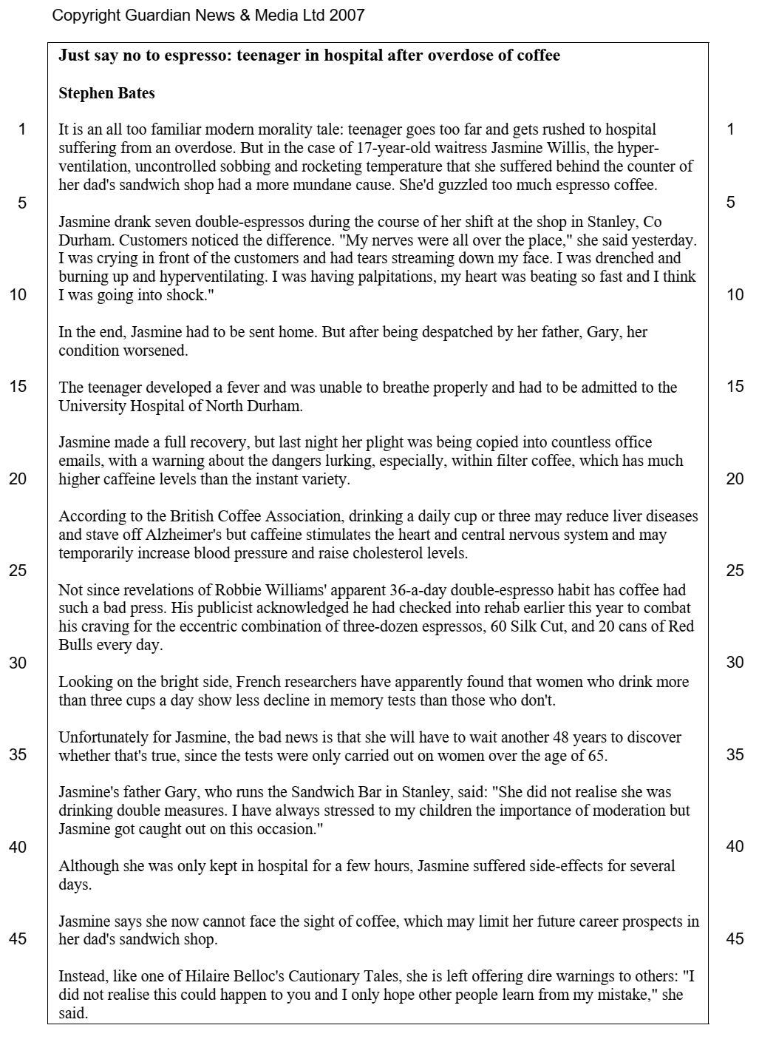
Task 3

Write a 1000-word essay based upon the following questions (1-4). Answer them based on your own beliefs, either informed by experience, intuition or research. Submit this essay with your application.

- What do you consider to be your main strengths as a teacher?
- What do you consider to be your main weaknesses?
- How could you help yourself develop these areas of weakness? Think of at least 2 practical ways.
- State and explain the extent to which you agree with one or two of the following statements:
- In order to properly master English, a learner has to know and understand its grammar.
- I tend to teach from my coursebook and have little time to create lessons for my learners.
- You have to know the mother tongue of your learners in order to really help them – most mistakes they make are because of L1 (their first language).

KEY BOOKS I WISH I’D AT LEAST LOOKED AT
BEFORE DOING THE DELTA

 | Richards, J.  Rogers, T.  or | Approaches + Methods in Language Teaching
 | Larsen-Freeman, D. | Techniques and Principles in Language Teaching
 | Parrott, M.  or | Grammar for English Language Teachers
 | Thornbury, S. | About Language
 | Brown, H. Douglas | Principles of Language Learning and Teaching
 | Brown, H. Douglas | Teaching by Principles
 | Hedge, T. | Teaching and Learning in the Language Classroom
 | Lewis, M. | The Lexical Approach
 | Lewis, M. | The English Verb
 | Lightbrown, P. Spada, N. | How Languages are Learned
 | Willis, J + Willis, D. | Challenge & Change in Language Teaching

...and once I’m done with those...

Batstone, R. | Grammar
Cook, G. | Discourse
Nuttall, C. | Teaching Reading Skills in a Foreign Language
Thornbury, S. | How to Teach Grammar
Thornbury, S. | How to Teach Speaking
Thornbury, S. | How to Teach Vocabulary
Thornbury, S. | Uncovering Grammar
Underhill, A. | Sound Foundations
Webb, S.  Nation, P. | How Vocabulary is Learned
Wilson, JJ. | How to Teach Listening

LESSON PLAN TEMPLATE

(use this or make sure you include the given information)

TIME / LENGTH
LEVEL
No. OF STUDENTS
AIMS
ASSUMPTIONS
LANGUAGE ANALYSIS
(features of the meaning, form, phonology and appropriacy / style of your target language)
ANTICIPATED PROBLEMS AND SOLUTIONS
MATERIALS AND AIDS
PERSONAL AIMS

Commentary (write 200-500 words regarding the thinking behind the plan, the rationale for choice of materials and sequencing):

Stage | Procedure | Inter-  action | Time | Aim

